Output of TIC TAC TOE GAME

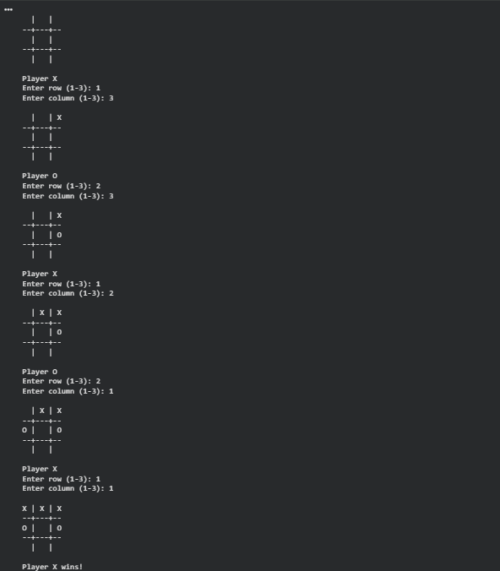

OUTPUT OF VACUUM CLEANER(SIMPLE REFLUX AND GOAL BASED)
